Reading Weather Information and Emergencies from the Cloud and Updating them on the device Dashboard using IoT Services

Abstract:

The system proposed in this project is an advanced solution for monitoring the weather conditions at a particular place and make the information visible anywhere in the world. The technology behind this is Internet of Things (IoT), which is an advanced and efficient solution for connecting the things to the internet and to connect the entire world of things in a network. Here things might be whatever like electronic gadgets, sensors and automotive electronic equipment. The proposed system deals with monitoring and keeps track of temperature, humidity, wind speed and direction, rainfall amount etc. The system displays these readings in real time on a display. It also keeps track of historical information on an hourly and daily basis. In this system the data can be displayed on LCD and sends the information to the web page and then plot the sensor data as graphical statistics. The data updated from the implemented system can be accessible in the internet from anywhere in the world. Temperature sensors are widely used in engineering and scientific application, especially measurement systems. They are found within roadways in cold weather climates in order to help determine if icing condition exist. Indoors, temperature sensors are used in several climate control system including refrigerators, freezers, air conditioner and water heaters. A humidity sensor senses, measures and reports the relative humidity in the air. Sensors are the eyes and ears, but that can also measure temperature and detect vibration and rotation.

Keywords: Internet of Things (IoT) Embedded Computing System; Arduino UNO; Arduino Software, ESP8266, Smart Environment.

1

System Architecture:

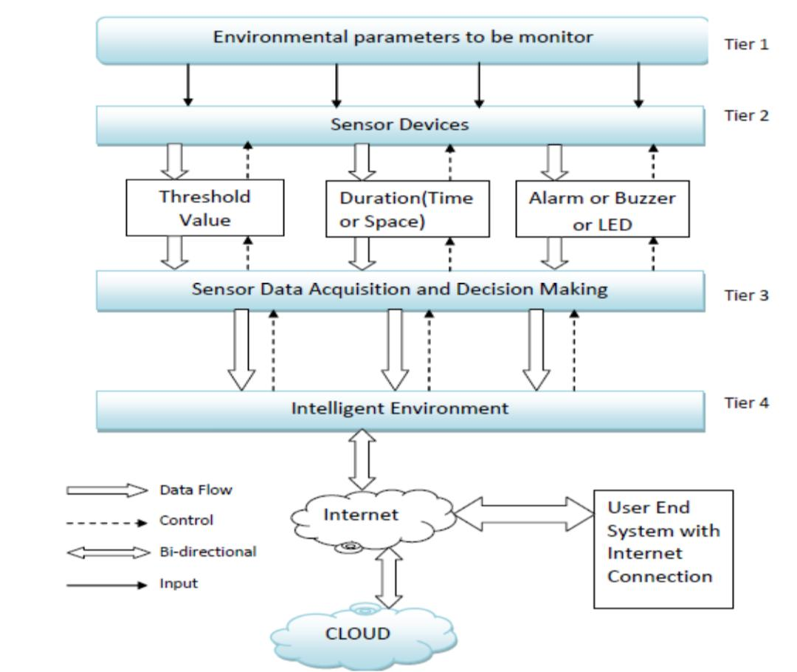

2